Review on Electric Vehicle Technology Development
ARUN KUMAR YADAV
(Associate Professor) Dept. of Electrical Engineering
Bansal Institute of Engineering and
Technology Lucknow, India
dr.arunkumaryadavee@gmail.com
KIRAN VERMA
(Student) Dept. of Electrical Engineering
Bansal Institute of Engineering and
Technology Lucknow, India
Abstract—Electric car research has been advanced in many nations in hopes of reducing reliance on fuel and environmental degradation. The deployment of EVs, especially rechargeable hybrid cars, is seen as a solution here to crisis of energy and ecological problems. In preparation for its potential future applications, this study offers a thorough analysis of the technical advancement of EVs. A summary of advanced components for electric vehicles (EVs) is presented, including those for storage, recharging, electric cars and controllers, and energy storage systems. Additional effort that this research provides is the discussion of technological problems and recently designed techniques for both the career improvement of EV security, durability, and performance.
Keywords—: Electric engine and controller, storage, charging stations, and electric cars with battery backup
Introduction
Issues with energy and the environment have arisen as just a consequence of the rising amount of automobiles with combustion engines that use fossil fuel based petroleum products [1]. Hence, many countries are using renewable power vehicles (NEVs) as substitutes for traditional transportation in hopes of reducing their oil dependency and the air quality that automobiles create [2-4].
Therefore hopes of reducing fuel consumption and exports, China, the largest automobile market in the world, has committed to developing NEVs [3,6]. Germany wants one million electric vehicles (EVs) operating in Europe by 2020 to cut Dioxide ( co2 ) emissions [7]; French and the UK similarly want to ban that domestic purchase of traditional automobiles by 2040 [2].
Many nations provided subsidies and special tax laws to encourage the use of NEVs, along with the UK's hybrid electric vehicles (PHEVs) vehicle incentives, America’s modern car tax credit, and Europe's and America's initiatives to promote the buying of ecological vehicles [3]. Hybrid cars (EVs), fuel vehicles, artificial gasoline cars, ethanol and methanol-fuelled vehicles are among the most prevalent NEVs that run on non-traditional fuel. From these NEVs, EVs are recognized as the most productive in achieving both environmental and socioeconomic objectives[7].
Vehicles have been in existence for more than a generation as a leading sector since the industrialization.
Battery Technology of EVs
Due to the fact that momentum cells are essential for sustaining an EV's rocket engine, any technology development among these batteries does have a substantial impact upon that EV industry [8]. The first electric vehicle (EV) was equipped with a rechargeable lead-acid battery. Numerous different types of power batteries are developed on the marketplace as a consequence of developments in rechargeable batteries [9]. These requirements of power cells have just not evolved significantly major progress in rechargeable batteries[10].
Battery packs must offer constant voltage, which is different from the needs of starting, lighting, and ignition batteries. In light of this, possessing greater generating capacity was essential[8-11]. Strong energy content, large specific power, with a high density of energy are also important .

Lead-Acid Batteries

French physicist Pierre Trappe created the regenerative lead-acid battery in 1860 [36]. It features a formative and reflective made of brown lead dioxide as well as a negative panel built from led metal, each of which is covered inside a solution created of a diluted sulphuric acid solution. A lead-acid battery contains usable electricity which may be transitioned into chemical energy to electrical power.

Lithium-ion Batteries
After being manufactured for the first time in a commercial setting by the Panasonic Corporation in 1991, rechargeable batteries became the standard for power storage and transportable electrical equipment. These are simultaneously lightweight, compact, and have a significant power storage capacity [48]. The rechargeable battery provides considerable advantages in the areas the particular power and power efficiency as comparison with the other types of cells in Figure 1.
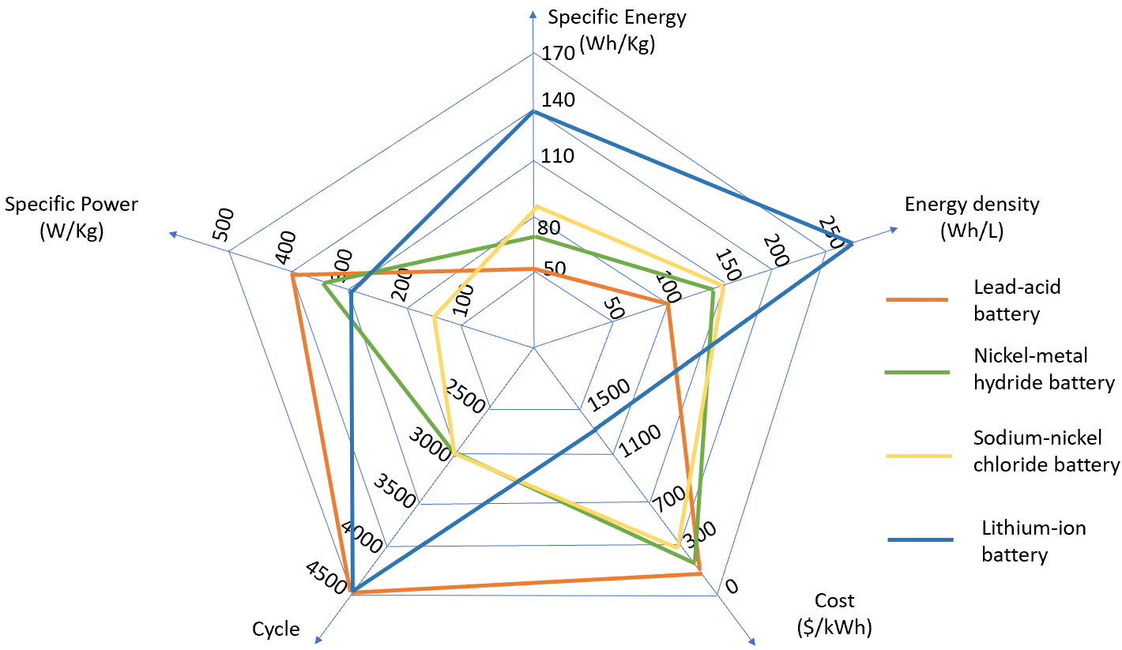
Fig:1 A review of the traits of multiple power sources.

Charging Technology

For BEVs, charging presents a different issue from battery capacity. The two fields of battery and charging technologies complement one another. Recharging equipment is essential and performs a big part with in BEV business since it helps EV drivers relieve their "range anxiety." Charging has become more streamlined and quick because to the technology's quick growth and the expansion of the infrastructure supporting it. Batteries powering Vehicles could be charged through conduction recharging, induction trying to charge, or batteries switching, each of which falls under a separate energy transfer mechanism [20]. EVs require various infrastructure and tools for charging according on the charging techniques.

Conduction recharging
Connectivity between the charger as well as the car is made possible by the conductivity rechargeable battery [20]. This energy transfer from of the source of energy towards the storage includes completely unvarnished connection. It is made up of AC/DC and converter conversions including some correction for power factor (PFC), and are capable of functioning as either an on- or even off rechargeable [21]. The connector for transmitting power is the converter. The procedure of delivering power generated by the electrical source towards the Energy storage system is known as recharging. A converter is needed to change AC again from energy grid towards DC even though EV charges must be recharged using DC. The essential architecture of the on-board rechargeable battery is displayed in Figure 2.
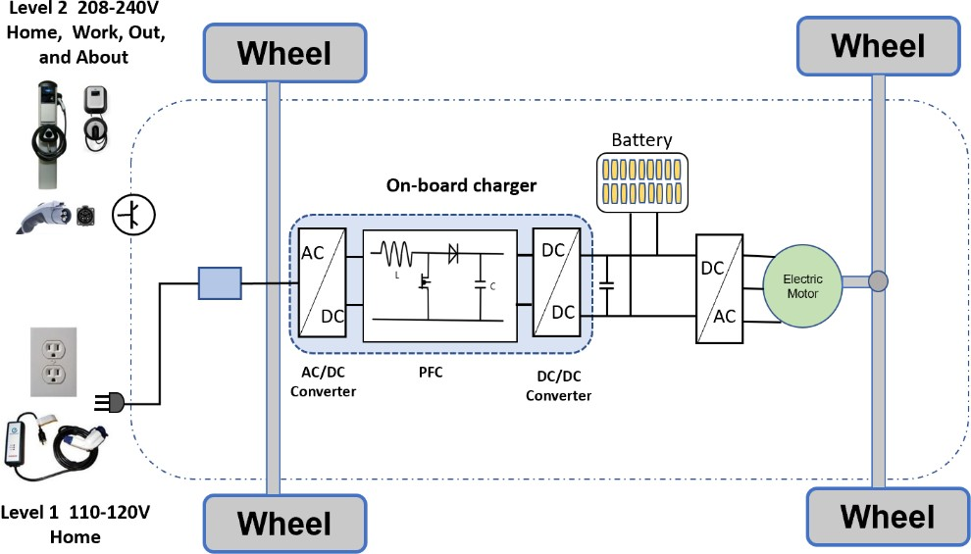
Fig: 2 The basic layout of an on- board battery charger

Battery Charger
Rechargeable systems may be divided into off-board as well as on converters including one or multiple power flowing based upon the direction of the load current. Batteries including one energy flow minimize the amount of equipment necessary and making interconnection easy. Batteries having two control transfer gem plus flow of energy [22]. That the on converter is utilized primarily for slowdown charging, as well as the required to charge procedure occurs within the Battery [20]. Another attraction with on converters for EVs would be that it considerably minimise the necessity of improve organizational performance for charging batteries. In grade 3, off-board connectors is employed for Generator wireless charging and may be attached towards both large cities and roadway filling stops. Those who generally require a AC connection with such a voltage of 480 V upwards of, and an external converter is necessary for controlled AC-DC conversion Bojrup and many others[20].
b) Methods of Conduction Rechargeable Charging
Due to the direct interface here between recharge as well as the car, any interface at greater electrical potential difference is prohibited [23]. With conductive charging, several charging methods are possible. The traditional charging methods are taper charging and trickle charging. They also include constant current (CC), constant voltage (CV), constant power (CP), and constant power (CC). To quickly charge batteries, a sophisticated method called CC/CV, which combines the aforementioned methods, is used. Additionally, fast charging can also be accomplished through the use of signal and reverse signal [20].

Induction recharging
Induction recharging, commonly referred to as removable batteries, is an increasingly adaptable yet simple required charging technique which has garnered significant interest. Rather than employing a straight connector, this device connected substantially prevents sparks that may be spurred along by connecting and disconnecting and increases the utilization of EVs in some circumstances, including such in but around petrol airports and pumping stations. Additionally, wireless charging may allow one to use dynamic charging, commonly known as charging while driving.

Battery Swapping
Unquestionably, battery changing is among the fastest and simplest charging techniques. EV users can easily swap out their worn-out battery for just a new one by visiting a battery replacement service. One of the essential aspects of something like a Base station is a transmission converter, together with AC/DC converter topologies, rechargeable batteries, mechanical devices, recharging towers, installations, process control, as well as other apparatus allowing cell exchanging and charging [25]. This same Base station does have an important predictor requirement from the perspective of the power grid. BSS, which is a collection of batteries, can additionally be utilized to maintain the grid by reintroducing power into it to balance the grid's load requirements. Regarding the perspective the System operators, a Base station provides a service that requires money to deliver a charge that is properly recharged.

EV Charging Standards
For EV charging, various nations have their unique regulations. It’s Independent Organization of Normalization, the Association of Skilled Machinists (Society of automotive engineers, Warren dale, PA, America), as well as specifications from of the Chinese Government Specification, the Japan Electric Car Union Requirements, as well as the International electro technical Commission (IEC, Geneva, Switzerland). The nations that now have some of the greatest global EV statistics, like the United States, the European Union, Korea, and Chinese, publicize these criteria.

Comparison of Rechargeable Mechanism
Among main recharging methods that are currently accessible for Battery usage include conductivity recharging, induction trying to charge, and cell changing. Conducting recharging is just the preferred recharging method when compared to the other two. It is inexpensive and somewhat easy [20].] A higher level of safety is provided by inductive charging technology. The charging device and vehicle assembly are in contactless communication, therefore there are no sparks.
With inductive charging, the driver must carefully park the car and place it in the charging zone. It is easy to use. Low charging efficiency and higher cost are inductive charging's key drawbacks [24].
As a fully charged battery is used to replace a drained one, battery swaps require the least amount of time to fully charge [25].

Electric Motors
The electric motor, which is at the core of an electric vehicle's propulsion system, converts the electrical energy stored in the battery into the mechanical energy required to propel the vehicle forward. Electric vehicles (EVs) have used a range of electric motor types having varying designs and technical breakthroughs. Switching reluctance motors, permanent magnet motors, & motor drives are examples of these (SRMs). The PM kind is most suited to meet automotive requirements [26].

Induction Motor
IMs were successfully deployed in the General Motors EV1. They are also utilized in Tesla electric vehicles such as the Model S and Roaster. Because of its reliability, durability, low maintenance requirements, established technology, and low cost, an IM is a viable solution for Vehicle applications in all commutators-less motor [27]. The main disadvantage of IMs is their poor performance under light loads [28]. Vector control is utilized to ensure that IMs meet the requirements of EV systems. Vector control, also known as field-oriented control (FOC), may give a large range of speed up to 3-4 times base speed, resulting in a fundamental shift in the control of the IM [29]. Therefore, the effectiveness in the high-speed range may degrade.

Permanent Magnet Brushless DC Motor
Because of its high efficiency and power density, PMBLDCs are commonly employed in electric vehicles. Its rotor is made of high-quality rare earth permanent magnet materials including samarium cobalt (Sm-Co) and neodymium-iron-boron (Nd-Fe-B) [29]. So, because rotor lacks windings, there is no rotor copper loss [27]. Rather than a commutator and brush gear, the PMBLDC accomplishes commutation with electronic switches that send synchronized current to the motor winding with the rotor position [30,31]. Because the rotor position is critical for PMBLDC regulation, it can be monitored using Hall Effect sensors, resolvers, or optical encoders [32].
The wide speed range, excellent efficiency, adaptability, and safety characteristics of the PMBLDC motor have sparked a great deal of curiosity for Hev, particularly in connection to electric propulsion system in-wheel technology [28].

Permanent Magnet Synchronous Motor (PMSM)
The PMSM is a superior option to other motors for propulsion technology because to its significant power density, highly efficient, and simple construction [33, 34]. There are two types of PMSMs: internal permanent magnetic synchronous motors (IPMSM) or surfaces mounted synchronous permanent magnet motors (SPMSM) (SM-PMSM). The SM-PMSM differs from the IPMSM in that it is easier to use and has less rotors inertia.

Switched Reluctance Motor
Switched reluctance electric motor have gained popularity for use in electric cars because of their outstanding performance, simple design, low cost, ruggedness, and fault tolerance, in addition to the fact that those who do not use exotic metals and thus avoid the high price and damage to the environment associated with resource exploitation and refining [35].

Charging Infrastructure
The availability of charging infrastructure for electric vehicles is critical to their widespread adoption. Electro mobility cannot be realized without the establishment of a dependable charging infrastructure network [36]. Coordination of the present condition of the charging infrastructure, awareness of how charging impacts the power network, and consideration of the adoption of a fair charging payment scheme are all required for the establishment of a robust charging communication infrastructure [36, 37].
- Organization of Charging Infrastructure
In responding to the "chicken-and-egg" challenge for EV deployment, governments in numerous countries, particularly those with substantial EV stocks, have supported charging infrastructure. There are considerable regional disparities in the accessibility of public charging infrastructure [36]. Between 2010 and 2013, the American Recovery and Reinvestment Act of 2009 offered federal funding through a few EV infrastructure programs to create around 18,000 public charging stations in the United States. This aided in the development of the country's initial charging infrastructure. Their government has greatly helped infrastructure building for charging stations and will continue to finance the sector. Trans nova (also known as "Enova"), a Norwegian organization, has constantly contributed 6 million euros to Norway's charging infrastructure in order to reduce Greenhouse Gas (GHG) emissions since 2009.
- The Challenges of Charging Networks
The growth of charging stations not only encourages the adoption of EVs, but also presents significant legislative challenges. The key challenges are the location of charging infrastructure and the impact of charging on the electricity network [36,37]. The former will have an impact on both the trustworthiness of the power grid and the expense of charging [37]. The latter may have an impact on the efficacy of the charging network as well as the possibility of future financing and support [38]. These two fields have been studied.
- Possibility of Fair Payment for EV Charging
Since, it is dependent on the condition and age of the battery, the possibility of having received a fair rate for Electric vehicle charging is also critical. A battery management solution can be used to assemble data on the condition of the batteries (BMS). Every motorist should be mindful of the length of time a car may be utilized after charging. Other factors that must be considered are battery capacity, charging pace, and power cost [39].
Emerging Technologies for the Future Development of EVs
EV technology has grown at a breakneck pace in recent years. EVs should provide more benefits than merely lower emissions. Vehicle-to-vehicle (V2V), vehicle-to-infrastructure (V2I), pedestrian-to-vehicle (V2P), and grid-to-grid (V2G) communications are examples of complex technologies that may be employed to increase real-time communication and mobility [33]. Vehicle-to-everything (V2X) refers to communication between autos and any smart device on the roadside [40, 41]. V2I communication, as a part of V2X, can improve driving efficiency by providing velocity judgments based on traffic light time and distance gap knowledge and minimizing the frequency of vehicle starting and stopping to make driving more effortless and consistent [41]. EV technology has advanced at an astonishing rate in recent years. EVs should have benefits other than reduced emissions. Vehicle-to-vehicle (V2V), Vehicle-to-infrastructure (V2I), Vehicle-to-pedestrian (V2P), and Vehicle-to-grid (V2G) connectivity are just a few of the complicated technologies that may be used to improve real-time communication and mobility [33]. The term "vehicle-to-everything" (V2X) alludes to communication between vehicles and any smart device on the roadside [40, 41]. V2I communication, a subset of V2X, can enhance driving efficiency by performing velocity assessments based on traffic light time and distance gap [41].

Conclusions
This article examines the advancement of key EV technology sectors, such as the battery, charging, electronic motor, charging infrastructure, and impending technologies. The development of battery technology is essential for EV adoption. In addition to the traditional lead-acid batteries, a wide variety of batteries are being used in EVs. The batteries used to power EVs include nickel-metal hydride cells, zebra batteries, and battery packs because they have greater specific energy, improved power efficiencies, and are more ecologically friendly. The most common batteries right now are lithium-ion ones. All electric cars may someday make use of ultra-capacitors and metal-air batteries; however this is still under development. Conducive chargers aim to charge EVs more rapidly, with less heat expansion, and without over-voltage by using CV, CC, CC-CV, or pulse charge currents. Charging is achievable without being limited by a physical wire connection thanks to inductive charging. Charging EVs may be done more simply and economically using dynamic charging technology. Battery replacement is another option for quick and easy charging. In addition to battery swapping, BSS may provide energy and services – to the distribution grid. Charging standards determine charging technology. IMs are used in Telesa electric cars. Vector control has enhanced the effectiveness of IMs under light loads. It is essential to take into account the rotor position while controlling PMBLDCs, which is commonly done via sensor-less control. The features of high power density and great efficiency, especially in the area of in-wheel technology, make the PMBLDC desirable for EV applications. PMSMs, especially the SM variant, have several EV applications. They feature a high density of power, excellent efficiency, and a straightforward construction. They also use FOC as just a torque control method. SRMs have lately acquired popularity since they do not require rare earth materials, are thus less costly, and offer great performance to meet the demands for EVs. If the acoustic noise problem could be overcome, future SRM technology would've been widely used in EVs. The charging infrastructure is an important component of EV applications. The charging station network covers the charging network's administration, the technical challenges of the network, and the possibility of charging for free. EVs now function as a tool for moving individuals and items, similar to traditional autos, as well as a bridge for communications between EVs as well as all smart devices. These conversations have been made feasible in part by the innovative V2X technologies. Despite the fact that EV growth must overcome several technological challenges relating to battery, charging, electric motor, or incorporation of many other new technologies, we think that EVs will play an important role in people's lives in the future.

References
- Qiao, Q., Zhao, F., Liu, Z., He, X. and Hao, H., 2019. Life cycle greenhouse gas emissions of Electric Vehicles in China: Combining the vehicle cycle and fuel cycle. Energy, 177, pp.222-233..
- Li, C., Negnevitsky, M., Wang, X., Yue, W.L. and Zou, X., 2019. Multi-criteria analysis of policies for implementing clean energy vehicles in China. Energy Policy, 129, pp.826-840.
- Li, W., Long, R. and Chen, H., 2016. Consumers’ evaluation of national new energy vehicle policy in China: An analysis based on a four paradigm model. Energy Policy, 99, pp.33-41.
- Hu, Z. and Yuan, J., 2018. China’s NEV market development and its capability of enabling premium NEV: Referencing from the NEV market performance of BMW and Mercedes in China. Transportation Research Part A: Policy and Practice, 118, pp.545-555.
- Xiong, S., Ji, J. and Ma, X., 2019. Comparative life cycle energy and GHG emission analysis for BEVs and PHEVs: A case study in China. Energies, 12(5), p.834.
- Gong, H., Wang, M.Q. and Wang, H., 2013. New energy vehicles in China: policies, demonstration, and progress. Mitigation and Adaptation Strategies for Global Change, 18, pp.207-228.
- Hannan, M.A., Lipu, M.H., Hussain, A. and Mohamed, A., 2017. A review of lithium-ion battery state of charge estimation and management system in electric vehicle applications: Challenges and recommendations. Renewable and Sustainable Energy Reviews, 78, pp.834-854.
- Pelegov, D.V. and Pontes, J., 2018. Main drivers of battery industry changes: Electric vehicles—A market overview. Batteries, 4(4), p.65.
- and recommendations. Renewable and Sustainable Energy Reviews, 78, pp.834-854.
- Saxena, S., Le Floch, C., MacDonald, J. and Moura, S., 2015. Quantifying EV battery end-of-life through analysis of travel needs with vehicle powertrain models. Journal of Power Sources, 282, pp.265-276.
- Alshahrani, S., Khalid, M. and Almuhaini, M., 2019. Electric vehicles beyond energy storage and modern power networks: Challenges and applications. IEEE Access, 7, pp.99031-99064.
- Reddy, T.B., 2011. Linden’s handbook of batteries. McGraw-Hill Education.
- Kobayashi, H., 2022. Evaluation of Toyota’s Strategy for BEV in Overtaking Tesla: Based on the Theories of Dynamic Managerial Capabilities and Ordinary Capabilities. Journal of Strategic Management Studies, 14(1), pp.49-66.
- Horkos, P.G., Yammine, E. and Karami, N., 2015, April. Review on different charging techniques of lead-acid batteries. In 2015 Third International Conference on Technological Advances in Electrical, Electronics and Computer Engineering (TAEECE) (pp. 27-32). IEEE.
- Tie, S.F. and Tan, C.W., 2013. A review of energy sources and energy management system in electric vehicles. Renewable and sustainable energy reviews, 20, pp.82-102.
- Chau, K.T., Wong, Y.S. and Chan, C.C., 1999. An overview of energy sources for electric vehicles. Energy Conversion and Management, 40(10), pp.1021-1039.
- Akinyele, D.O. and Rayudu, R.K., 2014. Review of energy storage technologies for sustainable power networks. Sustainable energy technologies and assessments, 8, pp.74-91.
- Hannan, M.A., Hoque, M.M., Mohamed, A. and Ayob, A., 2017. Review of energy storage systems for electric vehicle applications: Issues and challenges. Renewable and Sustainable Energy Reviews, 69, pp.771-789.
- Manzetti, S. and Mariasiu, F., 2015. Electric vehicle battery technologies: From present state to future systems. Renewable and Sustainable Energy Reviews, 51, pp.1004-1012.
- Rahman, I., Vasant, P.M., Singh, B.S.M., Abdullah-Al-Wadud, M. and Adnan, N., 2016. Review of recent trends in optimization techniques for plug-in hybrid, and electric vehicle charging infrastructures. Renewable and Sustainable Energy Reviews, 58, pp.1039-1047.
- Kumar K, J., Kumar, S. and VS, N., 2022. Standards for electric vehicle charging stations in India: A review. Energy Storage, 4(1), p.e261.
- Zhang, X., Rao, R., Xie, J. and Liang, Y., 2014. The current dilemma and future path of China’s electric vehicles. Sustainability, 6(3), pp.1567-1593.
- Sul, S.K. and Lee, S.J., 1995. An integral battery charger for four-wheel drive electric vehicle. IEEE Transactions on Industry Applications, 31(5), pp.1096-1099.
- Budhia, M., Covic, G. and Boys, J., 2010, November. A new IPT magnetic coupler for electric vehicle charging systems. In IECON 2010-36th Annual Conference on IEEE Industrial Electronics Society (pp. 2487-2492). IEEE.
- Ban, M., Yu, J., Li, Z., Guo, D. and Ge, J., 2019. Battery Swapping: An aggressive approach to transportation electrification. IEEE Electrification Magazine, 7(3), pp.44-54.
- Lee, H.K. and Nam, K.H., 2016. An overview: Current control technique for propulsion motor for EV. The Transactions of the Korean Institute of Power Electronics, 21(5), pp.388-395.
- Sutikno, T., Idris, N.R.N. and Jidin, A., 2014. A review of direct torque control of induction motors for sustainable reliability and energy efficient drives. Renewable and sustainable energy reviews, 32, pp.548-558.
- Kumar, M.S. and Revankar, S.T., 2017. Development scheme and key technology of an electric vehicle: An overview. Renewable and Sustainable Energy Reviews, 70, pp.1266-1285.
- Ameid, T., Menacer, A., Talhaoui, H. and Azzoug, Y., 2018. Discrete wavelet transform and energy eigen value for rotor bars fault detection in variable speed field-oriented control of induction motor drive. ISA transactions, 79, pp.217-231.
- Singh, B. and Singh, S., 2009. State of the art on permanent magnet brushless DC motor drives. journal of power electronics, 9(1), pp.1-17.
- Chan, C.C. and Chau, K.T., 2001. Modern electric vehicle technology (Vol. 47). Oxford University Press on Demand.
- Kim, T., Lee, H.W., Parsa, L. and Ehsani, M., 2006, October. Optimal power and torque control of a brushless DC (BLDC) motor/generator drive in electric and hybrid electric vehicles. In Conference record of the 2006 IEEE industry applications conference forty-first IAS annual meeting (Vol. 3, pp. 1276-1281). IEEE.
- Carpiuc, S.C. and Lazar, C., 2017. Modeling of synchronous electric machines for real-time simulation and automotive applications. Journal of the Franklin Institute, 354(14), pp.6258-6281.
- Feng, G., Lai, C., Iyer, K.L.V. and Kar, N.C., 2017. Improved high-frequency voltage injection based permanent magnet temperature estimation for PMSM condition monitoring for EV applications. IEEE Transactions on Vehicular Technology, 67(1), pp.216-225.
- Gan, C., Wu, J., Sun, Q., Kong, W., Li, H. and Hu, Y., 2018. A review on machine topologies and control techniques for low-noise switched reluctance motors in electric vehicle applications. IEEE Access, 6, pp.31430-31443.
- Hall, D. and Lutsey, N., 2017. Emerging best practices for electric vehicle charging infrastructure. The International Council on Clean Transportation (ICCT): Washington, DC, USA, 54.
- Liu, J., 2012. Electric vehicle charging infrastructure assignment and power grid impacts assessment in Beijing. Energy policy, 51, pp.544-557.
- San Román, T.G., Momber, I., Abbad, M.R. and Miralles, Á.S., 2011. Regulatory framework and business models for charging plug-in electric vehicles: Infrastructure, agents, and commercial relationships. Energy policy, 39(10), pp.6360-6375.
- Babic, J., Carvalho, A., Ketter, W. and Podobnik, V., 2015. Economic benefits of smart parking lots. In Proceedings of the Erasmus Energy Forum (pp. 1-8).
- Li, M., Wu, X., He, X., Yu, G. and Wang, Y., 2018. An eco-driving system for electric vehicles with signal control under V2X environment. Transportation Research Part C: Emerging Technologies, 93, pp.335-350.
- Bo, Z., Di, W., MinYi, Z., Nong, Z. and Lin, H., 2019. Electric vehicle energy predictive optimal control by V2I communication. Advances in Mechanical Engineering, 11(2), p.1687814018821523.

